CHEMICAL ENGINEERING TRANSACTIONS  VOL. XX, 2024 | A publication of
The Italian Association
of Chemical Engineering
Online at www.cetjournal.it

Guest Editors: Rubens Maciel Filho, Eliseo Ranzi, Leonardo Tognotti
Copyright © 2022, AIDIC Servizi S.r.l.
ISBN 978-88-95608-90-7; ISSN 2283-9216

Mixotrophic and Heterotrophic Metabolism in Brewery Wastewater by Chlorella vulgaris: Effect on Growth, FAME Profile, and Biodiesel Properties

Tea Miotti¹, Francesco Sansone¹, Veronica Lolli², Alessandro Concas^{3,4}, Giovanni Antonio Lutzu⁵*
¹ Dipartimento di Chimica, Scienze della Vita e della Sostenibilità Ambientale, Università di Parma, Parco Area delle Scienze 11/A, 43124 Parma (PR), Italia
²Dipartimento di Scienze degli Alimenti e del Farmaco, Università di Parma, Parco Area delle Scienze 27/A, 43124 Parma (PR), Italia
³Dipartimento di Ingegneria Meccanica, Chimica e dei Materiali, Università di Cagliari, Piazza d’Armi, 09123 Cagliari (CA), Italia
⁴Centro Interdipartimentale di Ingegneria e Scienze Ambientali, via San Giorgio 12, 09123 Cagliari (CA), Italia
⁵Teregroup Srl, via David Livingstone 37, 41123 Modena, (MO), Italia
*gianni.lutzu@teregroup.net is
Abstract
Microalgae show potential as renewable and environmentally friendly fuel resources. Wastewaters (WWs) can be utilized as growth media, reducing the associated cultivation costs. Therefore, the aim of this study was to investigate how organic-rich WWs affect the growth and fatty acid methyl esters (FAME) profile of Chlorella vulgaris. This particular strain exhibits high biomass productivity and can thrive in a wide range of
WWs. It also has the ability to shift its metabolism from autotrophic to hetero/mixotrophic. Glycerol can serve as a means to direct metabolism towards lipids production. Consequently, C. vulgaris was cultivated in brewery wastewater (BWW) containing varying concentrations of glycerol under both metabolic conditions. When C. vulgaris was cultivated in a mixotrophic environment, it achieved a notably higher biomass yield compared to heterotrophic cultivation. The highest biomass yield, reaching 1.33 g L⁻¹, was achieved utilizing 2 mL of glycerol in BWW, surpassing the control with 1.08 g L⁻¹. However, when a two-phase metabolism was applied, comprising the ten days of mixotrophy followed by the final five days in heterotrophy (MHB), the biomass yield was slightly lower than that obtained under continuous mixotrophic conditions. Nevertheless, it was still double the biomass obtained in a strictly heterotrophic environment. The FAME profile analysis revealed that, within the considered trophic conditions, the highest content of saturated fatty acids (SFA),
monounsaturated fatty acids (MUFA), and polyunsaturated fatty acids (PUFA) was observed during
mixotrophic cultivation with 10 mL of glycerol, mixotrophic cultivation with 4 mL of glycerol, and MHB with 4 mL of glycerol (35.36%wt, 46.89%wt, and 31.60%wt, respectively). An initial examination of the saturated and unsaturated components of the FAME suggests that lipids extracted from C. vulgaris biomass cultivated mixotrophically and heterorophically in BWW could potentially serve as a valuable feedstock for biodiesel production.
  - Introduction
Microalgae are currently recognized as a valuable tool for harnessing environmentally friendly resources, thanks to their high biomass and lipids content, making them well-suited for biofuels production (Concas et al., 2021a). Wastewaters (WWs) typically contain significant quantities of nutrients, including carbon (C), nitrogen (N), phosphorus (P), and trace elements, essential for supporting algal growth (Concas et al., 2021b). The ability of microalgae to effectively integrate their growth with the biological WWs treatment has been extensively demonstrated (Lutzu et al., 2020a). The presence of both inorganic and organic C within WWs allows certain algae strains to adjust their metabolism from autotrophic to mixotrophic, depending on the available carbon sources. The utilization of WWs from the food industry, such as dairy, brewery and molasses sugarcane, as a nutrient medium for microalgae cultivation, has been firmly established (Lutzu et al., 2016, Miotti et al., 2022, Vitali et al., 2022). Furthermore, the introduction of exogenous organic C sources during heterotrophic/mixotrophic microalgae cultivation stimulates the cell’s metabolic machinery, leading to enhanced lipids production (Yun et al., 2021). In this context, glycerol, a by-product of biodiesel industry, can be regarded as a metabolic stress inducer that promotes lipids production (Gaignard et al., 2021).
The microalga Chlorella vulgaris has the capability to accumulate lipids and produce biodiesel under appropriate stress conditions (Maltsev et al., 2023). Additionally, this strain can transition from its exclusive photoautotrophic or heterotrophic metabolism to a mixotrophic one, resulting in increased biomass production. The impact of heterotrophy and mixotrophy on lipids content and FAME composition has been extensively studied for various Chlorella strains (Miotti et al. 2023; Vitali et al., 2022). BWW is notably rich in sugars, with high BOD and COD values ranging from 0.1 to 100 g L⁻¹, which can significantly boost microalgae biomass productivity when present in the culture medium (Lutzu et al., 2016, Amenorfenyo et al., 2017). Therefore, in examining the potential use of BWW as medium for microalgae cultivation, this study investigates the impact of different concentration of glycerol as additional organic sources capable of inducing stress on lipids metabolism in C. vulgaris, affecting biomass accumulation and lipids production. The study further conducts a detailed analysis of the FAME profile, considering the addition of glycerol under heterotrophic, mixotrophic and a two-phase mixo-heterotrophic metabolism.

2. Material and Methods
2.1 Experimental setup

Chlorella vulgaris metabolic behaviour was monitored for 17 days under heterotrophy (HB) and mixotrophy (MB) condition using brewery WW (BWW) as culture medium and Doucha medium as control, respectively. A two-phase metabolic condition (MHB) was obtained cultivating Chlorella for the first 12 days in mixotrophy and the last 5 days in heterotrophy. For each of the three metabolic conditions (HB, MB and MHB) three replicates were run with four different concentrations of glycerol: 0 mL, 2 mL, 4 mL, and 10 mL.

2.2 Inoculums and wastewater preparation
The strain used in this study, C. vulgaris SAG 211-12, was obtained from the culture collection of algae at the University of Gottingen, Germany. Detailed chemical composition of the culture maintenance media is available on the SAG official website. All the details on the inoculums culture maintenance have been provided in our previous work (Miotti et al. 2023). Inoculums was cultured for about one week once it reached the end of exponential growth phase. BWW was collected from a brewery facility “Birrificio Ducale”, located in Soragna (PR), Italy. An average range of the main chemical-physical parameters for this effluent is shown in Table 1. Once collected BWW was stored at 4 ºC before its use. Later it was filtered using glass filter microfiber disks (GF/CTM 47 mm diameter, Whatman, Incofar Srl, Modena, MO, Italy), deprived of solid materials and then sterilized at 121 ºC and 0.1 MPa for 20 min before microalgae cultivation.
2.3 Culture medium and algae cultivation
1 L glass flasks, referred as PBRs, were used for algae cultivation. PBRs were covered with a cotton cup for air diffusion (0.03% CO₂ v v⁻¹) and daily shaken manually at room temperature. They were illuminated with a photoperiod of 12 h light/12 h dark by white fluorescent lamps providing a light intensity of 85 µmol m⁻² s⁻¹. The initial working volume of the PBRs and cell concentration were 500 mL and 0.1 g L⁻¹, respectively. The culture medium used as control was a modified Doucha whose composition is reported in our previous work (Miotti et al. 2023). After two weeks of cell growth, the cultures were centrifuged at 9722 g RCF⁻¹ for 10 min. The liquid phase was separated from the pellet and the latter used for fatty acids methyl esters (FAME) analysis.
2.4 Characterization of microalgae growth pattern
Microalgae growth in the culture was monitored by measuring the optical density (OD) at 680 nm. The detailed procedure adopted for monitoring algal growth was reported in Lutzu et al. (2020b). The cell concentration (dry weight) X_{dw} (g L⁻¹), specific growth rate (μ), and doubling time (t_{d}) calculations were performed according to Zhou and Dunford (2017). The average biomass productivity (∆X) was expressed as:
(1)
where $t_{0}$ represent initial time of the cultivation period. The pH of the cultures was recorded using a pH-meter (HI 2210, Hanna Instruments, Woonsocket, RI, USA).

2.5 FAMEs determination
FAMEs were prepared according to a modified protocol reported by Lage and Gentili (2018), which has been exhaustively explained in our previous work (Miotti et al. 2023).
2.6 Data Analysis
All the experiments with algae and analytical tests were carried out in triplicate, with mean values for them. MataboAnalyst 5.0, tuned by the McGills University (Montreal, Canada), was used for the statistical analyses of the data. The regression equations correlating dry biomass concentration to OD and to µ were calculated using Microsoft Office Excel program (Excel 2016 Ink, Microsoft, USA).
  - Results and Discussion
    - C. vulgaris growth in brewery wastewater supplemented with glycerol
BWWs are characterized by huge amount of organic matter as demonstrated by the high BOD and COD values reported in Table 1. On the other hand, these effluents are poor in N and P.
Table 1: Range of main physical-chemical parameters of brewery wastewaters used for algae growth
BOD₅ (g L⁻¹) COD (g L⁻¹) | TSS (g L⁻¹) | TN (g TN (g L⁻¹) |  | TP (g L⁻¹) pH Reference
- 8.0-14.0 | 2.9-3.0 | 0.08-0.28 | 0.02-0.09 5.2-6.2 Chen et al., 2015
2.4 6.0 | - | 0.09 | 0.005 6.3 Sinbuathong et al., 2015
1.9 2.0 | 2.5 | - | 0.025 6.9 Enitan et al., 2016
- 2.1-5.8 | - | 0.005 | 0.44 6.9 Lutzu et al., 2016
Note: BOD = Biological Oxygen Demand, COD = Chemical Oxygen Demand, TSS = Total Suspended Solids, TN = Total Nitrogen, TP = Total Phosphorous.
To assess the impact of three trophic conditions - MB, HB and MHB - on C. vulgaris biomass production, a series of growth experiments were conducted using BWW as culture medium, with a standard Doucha medium serving as the control. Within each trophic condition, four concentrations of glycerol were examined. Table 2 reveals that MB, especially with 2 and 4 mL of glycerol, significantly increased the biomass concentration (1.33 g L⁻¹ and 1.32 g L⁻¹) compared to the control (1.08 g L⁻¹). Conversely, under MHB, only the addition of 4 mL of glycerol showed a notable increase in biomass compared to the control, with the other three concentrations showing no statistically significant differences. In HB, irrespective of glycerol supplementation, biomass accumulation was notably reduced compared to the control. Glycerol supplementation proved effective C. vulgaris growth under MB conditions, while its impact was negligible under HB and MHB. The µ in HB were lower than those obtained under MB conditions, approximately 3.5 time higher. Previous studies have indicated that algal µ can be significantly improved through nutrient supplementation (Lutzu et al., 2020b). In our study, µ was lower in the control, but when the brewery medium was amended with glycerol, µ increased, reaching the highest value of 0.547 day with 2 mL of glycerol in MHB. These findings align with prior research, demonstrating that mixotrophy significantly enhances Chlorella sp. biomass concentration and productivity in batch systems, compared to autotrophy and heterotrophy (Miotti et al., 2022, Vitali et al., 2022). A plausible explanation could be that mixotrophic cultures exhibit accelerated anabolism, attributed to adenosine triphosphate formed both in photochemical reactions during the photosynthesis and in mixotrophic reactions.
Numerous studies have highlighted the direct impact of the N:P ratio in the culture medium on the growth of C. vulgaris, with P identified as the limiting factor for its growth (Miotti et al., 2023). Choi and Lee (2015) investigated the influence of the N:P ratio (ranging from 5 to 70) on C. vulgaris cultivation in municipal WWs. They determined that the optimum N/P ratio for biomass productivity and nutrient removal varied between 5 to 20, contingent on the specific ecological conditions of the WWs. In our growth experiment, the N/P ratios of BWW under both MB and HB conditions deviate significantly from this optimum range. In contrast, only the control exhibits proximity to the optimal range with a N/P ratio of 13:1.
Table 2: Growth characteristics of C. vulgaris cultivated with brewery wastewater under different metabolic conditions
Growth medium | µ (day⁻¹) | t_{d} (day) | X_{max} (g L⁻¹) ∆X (mg L⁻¹ day⁻¹)
CTRL | 0.119 ± 0.013 | 5.81 ± 0.34 | 1.08 ± 0.06 82 ± 0.004
MB0 | 0.221 ± 0.012 | 3.17 ± 0.17 | 1.13 ± 0.02 66 ± 0.001
MB2 | 0.194 ± 0.007 | 3.57 ± 0.12 | 1.33 ± 0.05 78 ± 0.003
MB4 | 0.236 ± 0.01 | 2.94 ± 0.13 | 1.32 ± 0.01 78 ± 0.001
MB10 | 0.162 ± 0.039 | 4.48 ± 1.25 | 1.11 ± 0.01 65 ± 0.001
HB0 | 0.166 ± 0.002 | 4.17 ± 0.04 | 0.63 ± 0.01 42 ± 0.001
HB2 | 0.146 ± 0.009 | 4.75 ± 0.29 | 0.73 ± 0.01 46 ± 0.001
HB4 | 0.139 ± 0.008 | 5.01 ± 0.27 | 0.79 ± 0.02 49 ± 0.001
HB10 | 0.144 ± 0.013 | 4.83 ± 0.43 | 0.57 ± 0.01 38 ± 0.001
MHB0 | 0.516 ± 0.027 | 1.35 ± 0.07 | 1.04 ± 0.02 61 ± 0.001
MHB2 | 0.571 ± 0.077 | 1.23 ± 0.17 | 1.06 ± 0.03 63 ± 0.002
MHB4 | 0.547 ± 0.066 | 1.28 ± 0.15 | 1.14 ± 0.11 67 ± 0.007
MHB10 | 0.376 ± 0.019 | 1.84 ± 0.09 | 1.05 ± 0.06 66 ± 0.004
Note: µ: specific growth rate, t_{d}: doubling time, X_{max}: maximum biomass concentration, ∆X: average biomass productivity.
CTRL: Doucha medium, MB: mixotrophy in BWW, HB: heterotrophy in BWW, MHB: mixo-hetrotrophy in BWW. 0 mL, 2 mL,
4 mL, and 10 mL represent the amount of glycerol added to the media
Microalgae can utilize organic sources to shift from autotrophy to mixothophy. This phenomenon may elucidate why C. vulgaris, when cultivated in BWW, achieved a superior biomass concentration compared to the control, which lacks organic compounds. However, the scarcity of N and P, typical of wastes abundant in organic matter (Table 1), results in an imbalance in the C:N:P ratios compared to the optimal values for algae. This imbalance could lead to an excessive intracellular storage of C in the form of neutral lipids such as triacylglycerols rather than as proteins, which would require N (Gao et al., 2016).
3.2 FAME profile of C. vulgaris under mixotrophy and heterotrophy mode
The composition of FAs, including the length, branching of the carbon chain, and degree of unsaturation, is a crucial factor to consider when evaluating microalgal biomass as a potential feedstock for biodiesel production. Thus, the FAME profile of C. vulgaris, obtained through the esterification of FAs, is presented in Fig 1. FAME derived from MHB and HB exhibited higher percentages of long-chain compounds C16-C18 (94-97%wt and 96%wt, respectively) compared to those obtained under the control (93%wt) and MB (86-93%wt) (Fig 1b). The predominant FAs in MB were oleic (C18:1cis) > palmitic (C16:0) > linoleic (C18:2) > stearic (C18:0); in HB, they were C16:0 > C18:1cis > C18:1trans (elaidic acid) > C18:0 > C18:2; and in MHB, they were C18:1 > C16:0 > C18:2 > C16:3 (ω-3 palmitolinolenic) FA (Fig. 1a). Examining the impact of glycerol addition across the three trophic systems, it is observed that in MB, there were no statistically significant differences in the range 0-10 mL of glycerol, except for 4 mL of glycerol, which resulted in a % increase of C18:1. In HB, the addition of glycerol incrased the % of C18:4 (stearidonic FA) by more than 10 times and gradually increased the % of C18:1cis, while reducing that of C18:1trans. On the other hand, the presence of glycerol in MHB did not produce significant changes in the % of FAs. Remarkably, the addition of glycerol led to a nearly 50% reuction in the % of C18:0 in MB, HB and MHB, while substantially increasing the % of C16:0 in all the three trophic systems. When considering the degree of saturation and unsaturation (Fig 1b), glycerol addition resuted in an increase in unsaturated fatty acids (UFA) in all the systems - MB (64.63-67.42), HB (68.63-72.70%), and MHB (67.79-72.77%) - compared to the control (63.06%wt). Coversely, saturated fatty acids (SFA) decreased in MB (32.58-35.36%wt), HB (27.30-31.36%wt), and MHB (27.23-32.20%wt) compared to the control (36.94%wt). The highest % of UFA were observed in MHB with 10 mL of glycerol (72.77%wt), while the highest % of SFA, monunsaturated fatty acids (MUFA) and polyunsaturated fatty acids (PUFA) were found in MB with 10 mL of glycerol (35.36%wt), MB with 4 mL of glycerol (46.89%wt), and HB with 10 mL of glycerol (36.22%wt), respectively. When C. vulgaris was cultivated in MB and MHB with 2 and 10 mL of glycerol, the PUFA/SFA ratio exceeded 1. The highest PUFA/SFA ratio (1.28) was achieved when C. vulgaris was cultivated in HB with 10 mL the of glycerol, compared to the control (0.97). The PUFA/SFA ratio characterizes the distribution of SFA and UFA within cells. This ratio is closely tied to the nutritional requirements of microalgae, thus reflecting the composition of the culture medium. Microalgal metabolism can be adjusted based on the conditions in which microalgae are cultivated. Specifically, the lipids composition in algal membranes and cytoplasm can be reorganized in terms of SFA and UFA. For instance, a shift leading to an increased SFA portion can be achieved by upregulating the synthesis of neutral triglycerides at the expense of polar membrane lipids (rich in UFA), which may undergo partial degradation (Xin et al., 2018). This rearrangement of FAMEs can be accentuated under conditions of nutrients starvation, such as those encountered when C. vulgaris is cultured in BWW. C16:0 is one of the FAs suitable for biodiesel production. The content of this specific FA increased by 6-7 times in all trophic systems, both with and without glycerol. This suggests that the accumulation of C16:0 could be influenced by the reduced availability of macronutrients (such as N and P) in organic media compared to the control.
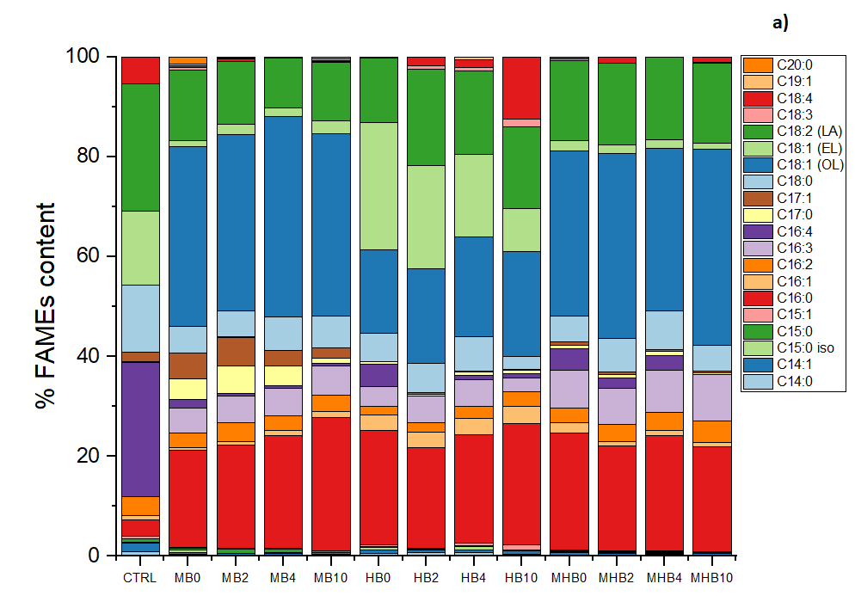
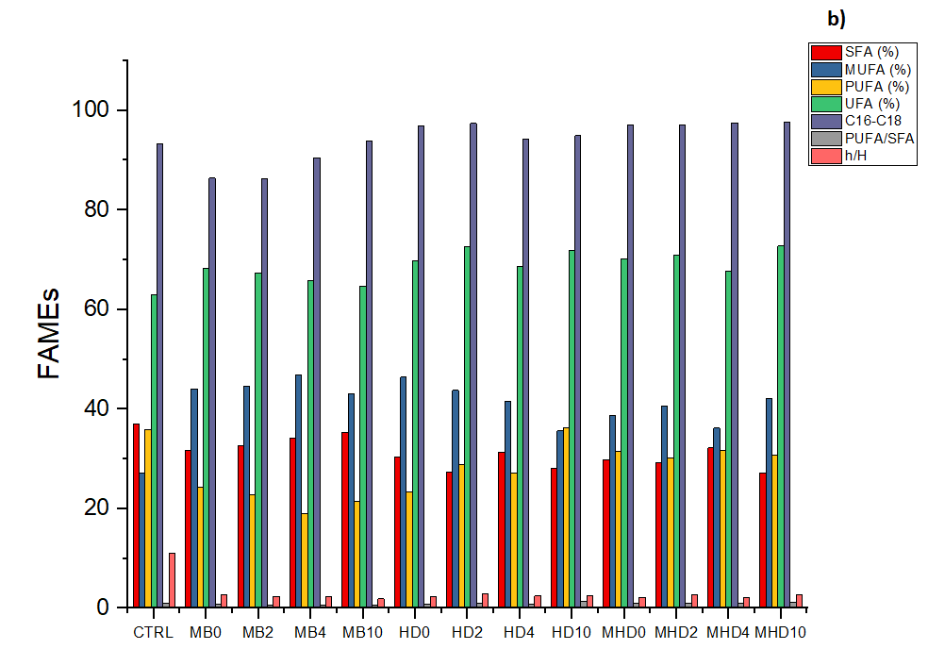
Oxidizability (OX), allylic position equivalent (APE), and bis-allylic position equivalent (BAPE) indices collectively contribute to the calculation of oxidation stability index (OSI). Following the methodology outlined by Pinto et al. (2021), an OSI can be generated through the FAMEs profile of microalgae. A high OSI value for an oil indicates stability, signifying its potential use for biodiesel production without the need for additional antioxidants during the OSI period. This period denotes the time until the quality of the oil/biodiesel remains unchanged, and biodiesel must be fully utilized for engine operation. According to the ASTM standard, oils can be classified as best, moderate, and poor. The best oils are characterized with an OSI ≥ 3 h, indicating stability and negating the need for added antioxidants. Interestingly, in all trophic conditions investigated in this study (MB, HB, and MHB), both with and without glycerol, the OSI values obtained for C. vulgaris through these indexes were > 3.90, except for the control (3.89) (data not shown). These values surpass 3.87, which is the OSI reported by Kumar and Sharma (2015) for the best-performing microalgae investigated (Scenedesmus obliquus). The heightened level of unsaturation, the high % of C16-C18 and C16:0 FAs, along with the elevated OSI index, suggest that biodiesel derived from C. vulgaris cultivated in BWW with the addition of glycerol could be well-suited for biodiesel production.

Figure 1. Fatty acids methyl ester profile (a) and total fatty acids (b) of C. vulgaris when cultivated under three different trophic conditions (MB, HB, MHB) in the presence of glycerol and in the control (CTRL)

Conclusions
The study investigated BWW as an organic waste source to enhance biomass production and FAME profiles in C. vulgaris with the addition of glycerol under three different trophic modes. The findings underscored that BWW could serve as a cost-effective source of organic nutrients, effectively stimulating microalgal growth. Furthermore, biomass production saw improvements with increasing glycerol content, particularly under mixotrophic conditions.
Regarding the FAME profile, C. vulgaris showcased its capacity to adjust internal metabolism, achieving enhanced unsaturation levels based on the trophic conditions employed. Specifically, the addition of glycerol under MHB conditions reduced FAs saturation while elevating unsaturation levels, resulting in higher MUFA and PUFA compared to the control. The obtained microalgal biomass from BWW cultivation thus emerges as a viable and cost-efficient option. Considering the FAME profile, particularly in terms of unsaturation levels, microalgal biomass obtained through mixotrophic cultivation of C. vulgaris could potentially serve as promising feedstock for biodiesel production.

References
Amenorfernyo D.K., Huang X., Zhang Y., Zeng Q., Zhang N., Ren J., Huang Q., 2019, Microalgae brewery wastewater treatment: Potentials, benefits and the challenges. International Journal of Environmental Research and Public Health, 16(11), 1910
Chen H., Chang S., Guo Q., Hong Y., Wu P., 2015, Brewery wastewater treatment using an anaerobic membrane bioreactor. Biochemical Engineering Journal 105, 321e31.
Choi H.J., Lee S.M., 2015, Effect of the N/P ratio on biomass productivity and nutrient removal from municipal wastewater. Bioprocess and Biosystems Engineering 38, 761–766.
Concas A., Steriti A., Pisu M., Cao G., 2021a, Experimental and theoretical investigation of the effects of iron on growth and lipids synthesis of microalgae in view of their use to produce biofuels. Journal of Environmental Chemical Engineering 9, 105349
Concas A., Steriti A., Pisu M., Cao G., 2021b, Experimental and theoretical investigation of the effects of iron on growth and lipids synthesis of microalgae in view of their use to produce biofuels. Journal of Environmental Chemical Engineering 9, 105349
Enitan A.M., Adeyemo J., Swalaha F.M., Bux F., 2015, Anaerobic digestion model to enhance treatment of brewery wastewater for biogas production using UASB reactor. Environmental Modeling and Assessment 20, 673e85.
Gaignard C., Zissis G., Buso D. 2021, Influence of different abiotic factors on lipids production by microalgae – a review. OCL 28, 57.
Gao B., Liu J., Zhang C., Van de Waal D.B., 2018, Biological stoichiometry of oleagineous microalgal lipids synthesis: The role of N:P supply ratios and growth rate on microalgal elemental and biochemical composition. Algal Research, 32, 353-361.
Kumar M., Sharma M., 2015, Assessment of potential of oils for biodiesel production. Renewable and Sustainable Energy Review, 44, 814-823.
Lage S., Gentili F.G., 2018, Quantification and characterization of fatty acid methyl esters in microalgae: Comparison of pretreatment and purification methods. Bioresource Technology 257:121-128
Lutzu G.A., Zhang W., Liu T., 2016, Feasibility of using brewery wastewater for biodiesel production and nutrient removal by Scenedesmus dimorphus. Environmental Technology, 37(12), 1568-1581.
Lutzu G.A., Ciurli A., Chiellini C., Di Caprio F., Concas A., Dunford N.T., 2020a, Latest developments in wastewater treatment and biopolymer production by microalgae, Journal of Environmental Chemical Engineering, 9(1), 104926.
Lutzu G.A., Marin M.A., Concas A. Dunford N.T., 2020b, Growing Picochlorum oklahomensis in hydraulic fracturing wastewater supplemented with animal wastewater. Water Air & Soil Pollution, 231, 457.
Maltsev Y., Kulikovskiy M., Maltseva S., 2023, Nitrogen and phosphorus stress as a tool to induce lipids production in microalgae. Microbial Cell Factories, 22, 239.
Miotti T., Pivetti L., Lolli V., Sansone F., Concas A., Lutzu G.A., 2022, On the use of agro-industrial wastewaters to promote mixotrophic metabolism in Chlorella vulgaris. Effect on FAME profile and biodiesel properties. Chemical Engineering Transactions 92, 55-60.
Miotti T., Sansone F., Lolli V., Concas A., Lutzu G.A., 2023, Dairy wastewater to promote mixotrophic and heterotrophic metabolism in Chlorella vulgaris. Effect on growth and FAME profile. Chemical Engineering Transactions 98, 81-86.
Pinto T.I., Coelho J.A., Pires B.I., Neng N.R., Nogueira J.M., Bordado J.C., Sardinha J.P., 2021, Supercritical carbon dioxide extraction, antioxidant activity, and fatty acid composition of bran oil from rice varieties cultivated in Portugal. Separations 8, 115.
Sinbuathong N., Somjit C., Leungprasert S., 2015, Feasibility study for biohydrogen production from raw brewery wastewater.International Journal of Energy Research 39,1769e77
Vitali L., Lolli V., Sansone F., Concas A., Lutzu G.A., 2022, Effect of mixotrophy on lipids content and fatty acids methyl esters profile by Chromochloris zofingiensis grown in media containing sugarcane molasses. BioEnergy Research 16, 1851-1861.
Vitali L., Lolli V., Sansone F., Concas A., Lutzu G.A., 2023, Lipids content and fatty acids methyl esters profile by Chromochloris zofingiensis under chemical and metabolic stress. Biomass Conversion and Biorefinery, https://doi.org/10.1007/s13399-023-04153-5
Xin Y., Shen C., She Y., Chen H., Wang C., Wei L., Yoon K., Han D., Hu Q., Xu J., 2018, Biosynthesis of triacylglycerol molecules with a tailored PUFA profile in industrial microalgae. Molecular Plant 12(4), 474-488.
Yun H-S., Kim Y-S., Yoon H-S., 2021, Effect of different cultivation modes (photoautotrophic, mixotrophic, heterotrophic) on the growth of Chlorella sp. and biocompositions. Frontiers in Bioenergy and Biotechnology 9, 774143.
Zhou N., Dunford N.T., 2017, Characterization of green microalgae and cyanobacteria isolated from Great Salt Plains. Transaction of the ASABE, 60(2), 283-290.

Answer to reviewer

REVIEWER # 1
Paper # 8
Title MIXOTROPHIC AND HETEROTROPHIC METABOLISM IN BREWER ............
by: Miotti T., Sansone F., Lolli V., Concas A., Lutzu G.A.

Scientific quality and significance of the work? :.............................good
Novelty & new insights into the problem?:......................................good
Is the presentation clear and understandable by most readers?:.......good
Is the paper following the Template rules ?:................................... yes
In case of acceptance, choose the format of presentation?:..............Poster

decision: accept after minor revisions

Comments by reviewer
The works highlight the crucial points about the microbial growth in different environment,
with a good point on the powerful circularity of wastewater (in this case, brewery one). However,
some changes need to be addressed by the authors:

- In the abstract, you don't need to start from the climate change, but as you do in the introduction,
you should address directly the work context.

Answer: We thank the reviewer for his/her valuable comment. Accordingly, we deleted from the abstract the part related to climate changes

- wastewater acronym is repeated. in the abstract is WW and in the introduction WWs. please,
chose one and adjust it all over the text.

Answer: We thank the reviewer for his/her comment. We would highlight the attention to the point that WW and WWs refer to the singular and the plural of the same word, respectively. WW stands for wastewater while WWs for wastewaters instead. We double checked the whole manuscript to uniform the use of only one acronym, that is WWs.

- in the experimental set-up chapter, there's no HB, MB or MHB cited. did you mean HD, MD,
MHD? please correct.

Answer. We thank the reviewer for his/her comment which allow us to verify this mistake. The reviewer was right in his/her comment since in some cases a different notation was used (i.e. HD, MD, MHD). The exact acronym used for the three metabolism are HB, MB, and MHB which have been reported along the whole manuscript. Accordingly, we deleted from the abstract the part related to climate changes

- in the number: 0.03% CO₂ v v-1, what v v-1 unit stands for? please, clarify or use SI unit
of measure.

Answer. we than the reviewer for his/her comment which allow us to clarify this point. The unit that we used, v v⁻¹ or v/v, stands for volume per volume, which is usually employed in expressing concentrations of gases in a mixture, indicating the proportion of a gas relative to the total volume of the mixture. In this specific case, every100 units of volume of the mixture (air-CO₂), 0.03 units of volume are occupied by carbon dioxide.

- "...centrifuged at 9722 g for 10 min" what "g" unit stands for? please, clarify or use SI
unit of measure.

Answer. We thank the Reviewer for letting us know this mistake and based on his/her request the unit of measure for the centrifuge has been changed accordingly. The reported unit of measure was incomplete. Actually, the correct way to report it is 9722 g RCF⁻¹, where RCF refers to the relative centrifugal force expressed in units of gravity (g), with a reference to the Earth’s gravity. RCF is a measure of the force applied to particles in a centrifuge and is proportional to both the rotational speed of the centrifuge (in this case 8000 RPM) and the distance of the particles from the axis of rotation.
- CTRL acronym is repeated, please remove any repetitions

Answer: we remove the acronym from the whole the manuscript and it was substituted by the whole word (control). We maintained the acronym only in Figure and Table

- Table 2 should not be truncated by the page change, put it in one page

Answer: We rearranged the Table 2 in a single page, avoiding to split it in two pages

- Table 2 columns names are in different formats and font, please adjust

Answer: we double checked the columns names in Table 2 and we found out that the reviewer was right in let us notice this mistake. Accordingly, ∆X (mg L⁻¹ day⁻¹) has been changed in the right format and font.

- in the sentence "Numerous studies have highlighted the direct impact of the N:P ratio in
the culture medium on the growth of C. vulgaris, with P identified as the limiting factor for
its growth" you should add at least a review reference about.

Answer: According to the reviewer’s request we add one reference after the cited sentence.

- Figure name should not be all bold, but only the "Figure X."

Answer: In the reported figure we put in bold only the expression “Figure 1”, while the remain caption was reported not in bold

REVIEWER # 2
Paper # 8
Title MIXOTROPHIC AND HETEROTROPHIC METABOLISM IN BREWER ...........
by:Miotti T., Sansone F., Lolli V., Concas A., Lutzu G.A.

Scientific quality and significance of the work? :.............................good
Novelty & new insights into the problem?:......................................good
Is the presentation clear and understandable by most readers?:.......good
Is the paper following the Template rules ?:................................... no
In case of acceptance, choose the format of presentation?:..............Lecture

decision: accept after minor revisions

Comments by reviewer
The work is interesting and well written, with a precise methodology.
In the following I will address some minor points to be revised:

- “can serve as a means” I would delete the “s” in “means”

Answer: According to the Reviewer’s request we remove “s” from the word means in the abstract

- “brewery waste (BWW)”, I would suggest to add “wastewater”

Answer: According to the Reviewer’s request brewery wastewater instead of brewery waste was changed in the abstract

- Intro: “can be regarded as a metabolic stress inducer that promotes lipid production” I would
say “lipids”. Check throughout the document, the word “lipid” appears very often as singular

Answer: We thank the reviewer for letting us know this inaccuracy. Therefore, we converted all the singular form of lipid in the manuscript into lipids

- the most critical point refers to FAME. Fatty acids are detected in their corresponding methyl
esters due to the derivatization process necessary for the GC analysis. However, algae do not
produce FAME but fatty acids (or the corresponding glycerides). This imprecision gives rise
to confusion (starting from the title). I would suggest to rewrite the title and modify the
text to better clarify this aspect.

Answer: We thank the reviewer for giving us the possibility to better clarify this point. The reviewer is right when saying that microalgae do not produce FAMEs but only fatty acids (FAs) or tri – di – mono - glicerides beyond other lipid categories. Such lipidic compounds can be all suitably converted through a simple transesterification procedure into a mixture of FAMEs, which can be used as a biofuel in the transportation sector. Since we were interested in this possible use of the algal lipids we preferred to talk about FAMEs rather than FAs which, on the other hand, represent only a fraction of all the lipids that can be converted into useful biofuels. So talking about FAs would have been reductive with respect to the goal of the study. Accordingly, we cannot meet the reviewer’s request to change the title and amend the text in this sense.

- Fig. 1 is bigger than the layout of the template

Answer: We thank the reviewer for letting us know this inaccuracy. Therefore, the Figure 1 has been reduced accordingly to met the template’s layout

- References, there is a comma between the surname and name that is not following the CET style

Answer: We thank the reviewer for letting us know this inaccuracy. Therefore, the comma between surname and name has been removed

